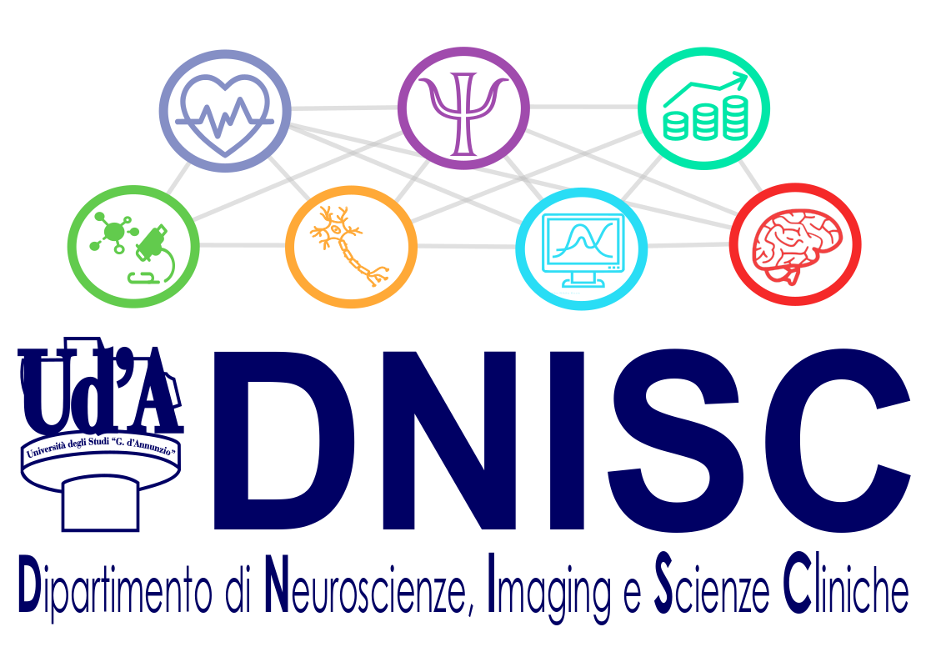
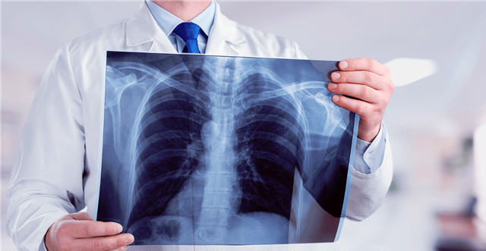
Department of Neuroscience, Imaging and Clinical Sciences

Bachelor Degree in Imaging and Radiotherapy Techniques (L-606)

The three-year Bachelor Degree Course in Imaging and Radiotherapy Techniques falls within the Class of degrees in Technical Healthcare (L / SNT3). Graduate Imaging and Radiotherapy Technicians authorized to carry out radiological investigations and services for diagnosis and therapy. They operate independently or in collaboration with the Radiologist and other health specialists, using ionizing radiation, both artificial and natural, of thermal energies, ultrasonic, nuclear magnetic resonance. They also participate to the physical and dosimetric protectionism, carrying out all these activity in the Public and Private healthcare.
During the first year, the students attend a series of Integrated Courses that provide them with basic knowledge (Anatomy, Physics applied to Radiological Sciences, Informatics, Physiology, Radiation protection, Radiobiology, General Pathology) necessary and indispensable for a structured and organic training course, together with specific knowledge allowing easy orientation in healthcare settings for facing the first internship experience.

During the second year, the students attend Courses aiming at providing theoretical, practical, applicative and procedural knowledge in the various areas of the current Diagnostic Imaging (Conventional Radiology, Senology, Computed Tomography, Magnetic Resonance, Nuclear Medicine, Oncological Radiotherapy, Interventional Angiography, Neuroradiology). The students will also carry out internship experiences (both on site
than in other Centers) to apply the knowledge and techniques they learned.

During the third year, the Course aims at the specialized study of the applied medical techniques, and at the consolidation of the knowledge gathered during the II Year. Moreover, the students will attend courses allowing them to identify and delineate the operation of the Healthcare professional in the world of work as well as providing them with a number of notions on the legal, bioethical and deontological principles of the practice of the profession of Imaging and Radiotherapy technician.

Information for ERASMUS INCOMING STUDENTS

First Semester (Autumn/Winter) Second Semester (Spring/Summer)
Lessons: October - January Lessons: March - May
Exams: February Exams: June - July

Click here https://en.unich.it/ugov/degree/5330 for details on courses.

Some courses are taught in English, all the others offer study material in English, tutorial in English, group activities in English and the possibility of taking the finale exam in English.

For further information please contact:

Prof. Raffaella Franciotti (Bachelor degree Erasmus delegate) raffaella.franciotti@unich.it
Prof. Giorgia Committeri (Departmental Erasmus delegate) giorgia.committeri@unich.it

For general information on the Department of Neuroscience, Imaging and Clinical Sciences please
click here: DNISC website

